Optional HW 4 Log
Rohan Krishnamurthi
12/13/2024

Assignment Info:
- Project Directory: projects/e31265/rsk9305/optional_4
- My wild type (WT) assigned samples: 2, 18, 20, 39, 42, 45
- My SNF2 mutant assigned samples: 14, 15, 31, 33, 42, 44

Preliminary Part
- Move ensemble folder to optional_4
- Move ERCC92.zip to optional_4 and unzip it
- In ensemble, make reference and annotation
  - cat sacCer.R64.fasta ERCC92.fa > sacCer.R64.ercc.fasta
  - cat sacCer.R64.gtf ERCC92.gtf > sacCer.R64.ercc.gtf
- Rebuild STAR index
  - In ensemble, create index_script.sh
  - Use sacCer.R64.ercc.fasta, sacCer.R64.ercc.gtf
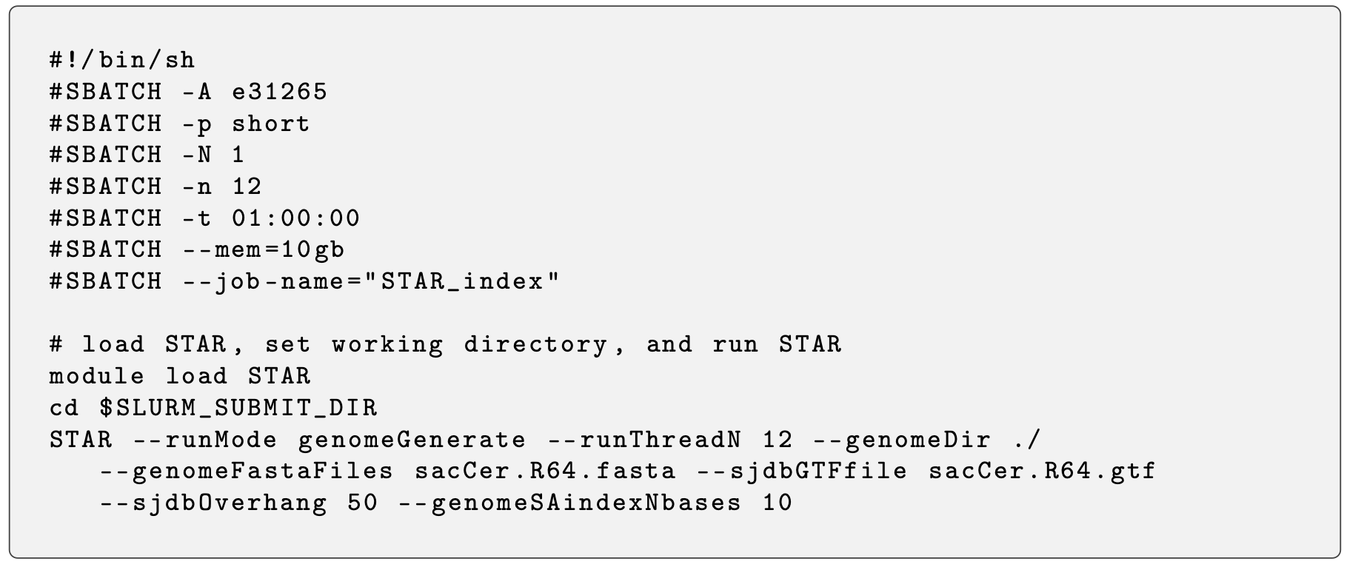
- Realign yeast samples
  - Run alignment file for each of the 14 replicates
  - List of files: count_table_files_4.1.txt
  - awk -f build_count_table.awk count_table_files_4.1.txt > count_table_4.1.txt
- You will get counts for differential expression analysis: count_table_4.1.txt

Differential Expression Analysis
- R script: opt_4A.R
- Correct order: do differential expression analysis on full set of genes, then filter for ERCCs
- Submit csv file showing only the particular ERCC spike-ins that are differentially expressed between the two conditions w/ p-value ≤ 0.05
  - File: yeast_ERCC_threshold_1.csv
- Submit a PCA plot that uses just the measured expression values of the spike-ins

ERCC spike-ins differentially expressed between the two conditions: ERCC-00077

PCA Plot using spike-ins:

Yes, the results of the PCA plot indicate that the spike-ins are generally differentially expressed. This is shown as the SNF2 samples are relatively clustered in the PCA plot, while the WT samples are more dispersed in the remainder of the PCA plot. Overall, the samples cluster distinctly by condition, indicating that the ERCC spike-ins generate systematic differences between conditions.

It is not a good idea to select for the ERCCs first and then do the differential expression analysis because ERCC spike-ins are intended to serve as controls for normalization, quality assessment, and benchmarking of other genes. Including all the genes and ERCCs in the initial differential expression analysis ensures proper normalization and dispersion estimation. Additionally, filtering for ERCCs after differential expression analysis allows one to examine their behavior as controls.

